**Chaos Program Binder**

**Spectrum Convergence Ratio (SCR)**

File name: batchSCR.m

* Runs in: Matlab R2017a
* File path: Computer > Local Disk (C:) > Evan > SCR > ‘batchSCR.m’

Location: Back wall computer in 1st phonosurgery room

Instructions

* Copy the .wav files to be analyzed into the ‘Input_wav_files’ folder
* ‘Run’ the ‘batchSCR.m’ script (if Matlab ever shows message about files not being in current folder, just change folder, don’t add to path)
* Multi-select the .wav files of interest from the ‘Input_wav_files’ folder (ctrl-shift to multi-select; will have to do this even if analyzing one sample-otherwise it throws an error)
* After files are selected, click ‘Open’
* The SCR results will show up in a file in the Results folder (Computer > Local Disk (C:) > Evan > SCR > Results)
* If transferring results to Excel, it’s easiest to copy all of the file names/output values into one column in Excel; separate into two columns by highlighting column and clicking Data > Text to Columns > Delimited with comma > Finish

**Rate of Divergence (ROD)**

File 1 name: batchMakeFragmentsForRODDialog.m

* Runs in: Matlab R2017a
* File path: Computer > Local Disk (C:) > Jonathan > Clint_Software > makeFragments > ‘batchMakeFragmentsForRODDialog.m’

Program 2: playDOSBox

* File path: Computer > Local Disk (C:) > Jonathan > Clint_Software > DOSBox-0.74 > playDOSBox

Location: Back wall computer in 1st phonosurgery room

Instructions

* Part 1
  + Copy .wav files of interest into the ‘makeFragments’ folder
  + ‘Run’ the ‘batchMakeFragmentsForRODDialog.m’ script (if Matlab ever shows message about files not being in current folder, just change folder, don’t add to path)
  + Click ‘select Dir’ and choose .wav files from ‘makeFragments’ folder (they won’t all highlight)
  + Click ‘Batch Make’ (single make doesn’t work)
  + Folders with 8 fragments for each .wav file will appear in the ‘makeFragments’ folder
  + Rename files so that the fragments corresponding to each .wav file can be easily distinguished
* Part 2
  + Open the ‘CDA22’ folder (Computer > Local Disk (C:) > Jonathan > Clint_Software > CDA22)
  + Delete any .dat files that are still there or move them into the ‘Old’ folder (if there are too many files, DOSBox may not work)
  + Copy fragments from Part 1 into the ‘CDA22’ folder
  + Open playDOSBox program (it’s a Windows Batch File; make sure you’re in DOSBox-0.74 folder)
    - It says CHAOS.dat not found- just click okay
  + Select fragment of interest (if not already at file list, click ‘T’)
  + Press ‘H’ to run (Lyapunov Exponent)
  + You can minimize screens if you want; make sure not to close any screens; *press Ctrl-F10 to release cursor from the window as it will get trapped*
  + You will need to open a new DOSBox window for each fragment that you run; if you need to you can run 30-40 fragments at one time, but if you run more the computer slows down significantly
  + Final ROD value for a specific .wav file
    - Take the average of the ROD values for the 8 fragments (the value given for the exponent; don’t need the margin of error)
    - Make sure every fragment is 100% done running (when done, %age disappears)

**TF32**

This program can be used to analyze voice samples for % jitter, % shimmer, SNR, and F0. It is downloaded on two of the phonosurgery computers in the 1st room.

* File > open > choose file
* If you want to choose a specific segment: click over the sample so that two white bars appear; the portion of interest should be between the bars
* View > open > Jitter > compute
* If you’re analyzing multiple files in one folder, you can just use the Next/Prev buttons in the main window to move between samples

**Praat**

This program can be used for visualizing the spectrogram of a voice sample, which we often use for assigning a voice type. It is installed on the back computer in the 1st phonosurgery room. Path: C > Evan > PRAAT Software

* First copy voice samples of interest into the ‘Voice Samples’ folder
* Open the Praat application and in the Praat Objects tab, click Open > Read from file
* Select a .wav file from the ‘Voice Samples’ folder
* Click ‘Analyze spectrum’ > ‘To Spectrogram’
* Change default settings to:

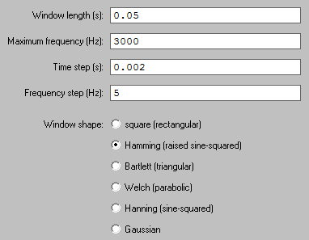

* Click ‘Ok’ > ‘View’

**Moving Window and Concatenation**

The moving window program is for splitting up a voice sample into multiple short, overlapping segments. Then each fragment can be analyzed separately to determine which portion of the sample is the “least perturbed” (instructions for this below). This is a useful method for choosing a portion of a longer vowel sample, because it increases consistency between subjects compared to subjectively choosing some portion. We have some papers published showing that using this moving window method has led to less variable results.

Olszewski AE, Shen L, **Jiang JJ**. Objective methods of sample selection in acoustic analysis of voice. Ann Otol Rhinol Laryngol. 2011; 120(3):155-61.

Shu M, **Jiang JJ**, Wiley M. The effect of moving window on acoustic analysis. J Voice. 2016; 30(1):5-10.

Moving window file name: wavCapture.m

* Runs in: Matlab R2013b
* All files are on the ‘Moving Window’ CD (ask Lab Manager for it); File path: E: Acoustic > Moving window program > wavCapture.m (make sure to right click > open with Matlab R2013b)

Location: Front wall computer in 1st phonosurgery room

Instructions

* When you open the Matlab file, click ‘Run’ and the wavCapture window should open 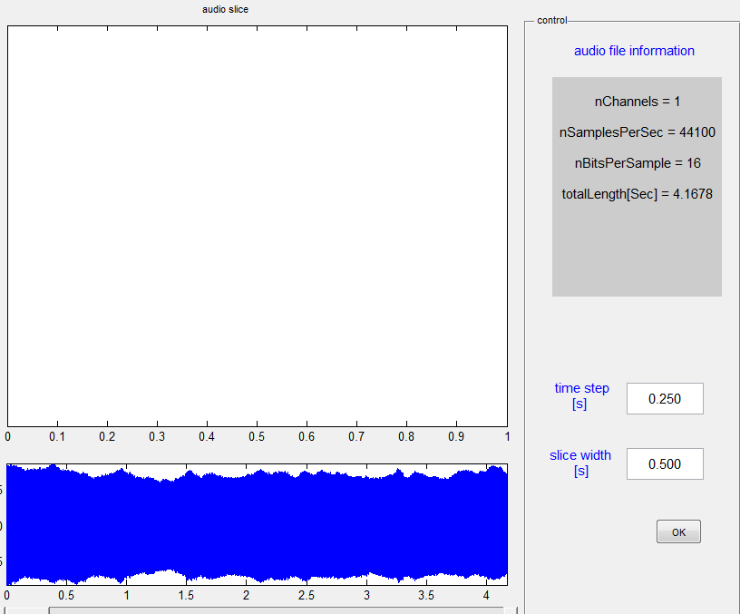
* In the top left corner there is a folder button where you can select your .wav file
* If you want to change and time step or slice width, you can do this in the bottom right corner
* Click OK > Save button (upper left corner) and the program should start slicing the sample
* A folder with all of the fragments will appear in the same location as the original file
* Ranking the fragments
  + If you’re looking for the least perturbed fragment you can separately analyze each fragment and build a “stability score”. Look at “Moving window ranking example” on desktop of front computer (you can see formula in row 3).
  + If you build a new spreadsheet with different parameters, make sure to be consistent with what should be considered the lowest rank for a given parameter (e.g. low NEDR is ranked low because it should increase as the voice becomes more disordered. High SCR is ranked low because the opposite trend from NEDR is observed).
  + In the example spreadsheet, the lowest ‘Final Rank’ is the “least perturbed” fragment.

**D2 & K2**

Script: DqKqScrip.m

Likely works in Matlab 2011b, but is not working in versions 2013b or 2017a. Needs to be debugged.